Practical – 6.1
AIM
To implement an Android application demonstrating programming of menus and dialogs for user interaction.
PROBLEM STATEMENT
Design and develop an Android application that uses an Options Menu with multiple menu items. On selecting a menu item, display an appropriate dialog to show information or to confirm user action, and perform the required operation based on the user’s response.
app
├── java
│ └── com.example.menudialogapp
│ └── MainActivity.java
├── res
│ ├── layout
│ │ └── activity_main.xml
│ ├── menu
│ │ └── menu_main.xml
│ └── values
│ └── strings.xml
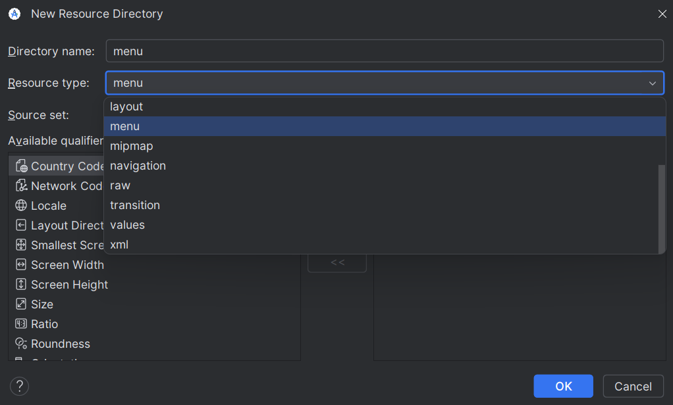
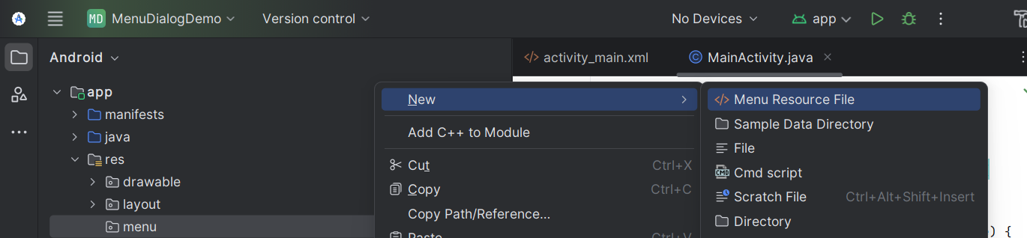
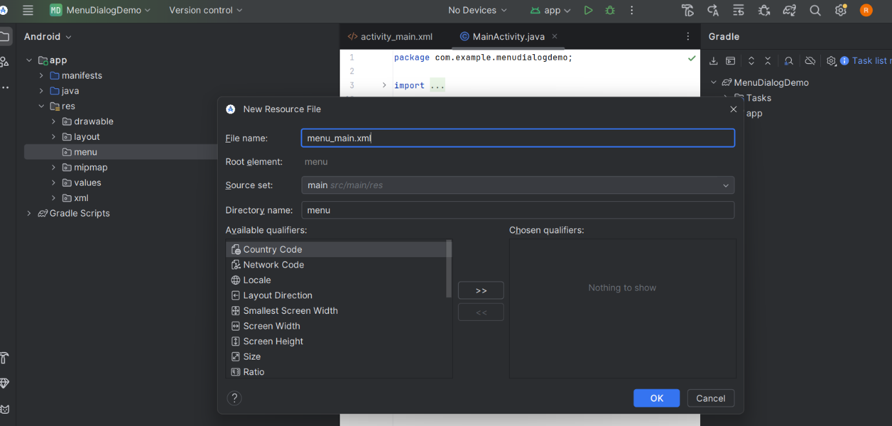

activity_main.xml:SourceCode:
<?xml version="1.0" encoding="utf-8"?>
<LinearLayout xmlns:android="http://schemas.android.com/apk/res/android"
xmlns:app="http://schemas.android.com/apk/res-auto"
android:layout_width="match_parent"
android:layout_height="match_parent"
android:orientation="vertical">
<!-- Toolbar -->
<androidx.appcompat.widget.Toolbar
android:id="@+id/toolbar"
android:layout_width="match_parent"
android:layout_height="wrap_content"
android:background="?attr/colorPrimary"
android:title="Menu Dialog App"
android:titleTextColor="@android:color/white"
app:popupTheme="@style/ThemeOverlay.AppCompat.Light"/>
<!-- Content -->
<LinearLayout
android:layout_width="match_parent"
android:layout_height="match_parent"
android:gravity="center"
android:orientation="vertical">
<TextView
android:id="@+id/txtMessage"
android:layout_width="wrap_content"
android:layout_height="wrap_content"
android:text="Select an option from menu"
android:textSize="20sp"
android:textStyle="bold"/>
</LinearLayout>

</LinearLayout>
MainActivity.java
package com.example.menudialogapp;
import android.content.DialogInterface;
import android.os.Bundle;
import android.view.Menu;
import android.view.MenuItem;
import android.widget.TextView;
import androidx.appcompat.app.AlertDialog;
import androidx.appcompat.app.AppCompatActivity;
import androidx.appcompat.widget.Toolbar;
public class MainActivity extends AppCompatActivity {
TextView txtMessage;
@Override
protected void onCreate(Bundle savedInstanceState) {
super.onCreate(savedInstanceState);
setContentView(R.layout.activity_main);
// Connect Toolbar to Action Bar
Toolbar toolbar = findViewById(R.id.toolbar);
setSupportActionBar(toolbar);
// Connect TextView
txtMessage = findViewById(R.id.txtMessage);
}
// Inflate Options Menu
@Override
public boolean onCreateOptionsMenu(Menu menu) {
getMenuInflater().inflate(R.menu.menu_main, menu);
return true;
}
// Handle Menu Item Clicks
@Override
public boolean onOptionsItemSelected(MenuItem item) {
int itemId = item.getItemId();
if (itemId == R.id.menu_about) {
showAboutDialog();
return true;
}
if (itemId == R.id.menu_reset) {
showResetDialog();
return true;
}
if (itemId == R.id.menu_exit) {
showExitDialog();
return true;
}
return super.onOptionsItemSelected(item);
}
// About Dialog
private void showAboutDialog() {
AlertDialog.Builder builder = new AlertDialog.Builder(this);
builder.setTitle("About App");
builder.setMessage("This application demonstrates the use of Options Menu and Alert Dialogs in Android.");
builder.setPositiveButton("OK", null);
builder.show();
}
// Reset Confirmation Dialog
private void showResetDialog() {
AlertDialog.Builder builder = new AlertDialog.Builder(this);
builder.setTitle("Confirm Reset");
builder.setMessage("Do you want to reset the displayed text?");
builder.setPositiveButton("Yes", new DialogInterface.OnClickListener() {
@Override
public void onClick(DialogInterface dialog, int which) {
txtMessage.setText("Text has been reset");
}
});
builder.setNegativeButton("No", null);
builder.show();
}
// Exit Confirmation Dialog
private void showExitDialog() {
AlertDialog.Builder builder = new AlertDialog.Builder(this);
builder.setTitle("Exit Application");
builder.setMessage("Are you sure you want to exit?");
builder.setPositiveButton("Yes", new DialogInterface.OnClickListener() {
@Override
public void onClick(DialogInterface dialog, int which) {
finish();
}
});
builder.setNegativeButton("No", null);
builder.show();
}
}
Menu_main.xml
<?xml version="1.0" encoding="utf-8"?>
<menu xmlns:android="http://schemas.android.com/apk/res/android">
<item
android:id="@+id/menu_about"
android:title="About App"/>
<item
android:id="@+id/menu_reset"
android:title="Reset Text"/>
<item
android:id="@+id/menu_exit"
android:title="Exit App"/>
</menu>

